SVTTA 30 TT Pinky Williams Trophy
SUNDAY 21st August 2022

8.00 AM START

COURSE WM30 - 2

Headquarters: Cambusbarron Community Hall, Cambusbarron, FK7 9NU

PROMOTED BY Scottish Veteran Time Trial Association under CTT
RULES & REGULATIONS

Organiser: George McLaughlan. 151 Netherton Road. Wishaw. Lanarkshire ML2 0AR Tel No: 01698-374201 email: george.mclaughlan@blueyonder.co.uk

Start Timekeeper: Catriona Stirling. Finish Timekeepers & Recorder: Mhairi Laffoley & Gavin Laffoley

Event Headquarters (open from 7.00 am)

Race Programme

Parking
Parking is available on-street or at car park at the HQ.

Please note. Parking will not be allowed in the adjacent Bowling Club car park nor will there be parking at the event start or finish.

Warming Up
The use of turbo trainers in Cambusbarron is to be discouraged, residents have made complaints in the past.

Competitors are requested not to warm up on the course after the event has started, as the road is busy near the start and finish. If you need to ride past the timekeepers or from Claytoll roundabout to the start, please take care not to interfere with those racing.

Course
The start is approximately 200 yards west of the junction of Kersebonny Road with the A811. Proceed on A811 to turn at Kippen Roundabout (island). Turn, and retrace to Clay Toll mini Roundabout (island). Turn and retrace to Kippen Roundabout. Turn and retrace to finish at entry to Falleninch Farm just after the motorway bridge, approximately half a mile before the Clay Toll roundabout.

Riding to the start
From the HQ to the Start is approximately 1.5 miles. From the HQ head north on the main street, take the 3rd turning on the right down Mill Hill, after about 500 yards, Take the first turning to the left into Mill Road which runs into Kersebonny Road. After a mile on this twisty narrow lane you come to the junction with A811. The start is approximately 200 yards to the left.

Warning
Please note that this is an “A” class road and therefore can be busy with traffic: care should be taken at all times and at the roundabouts in particular.

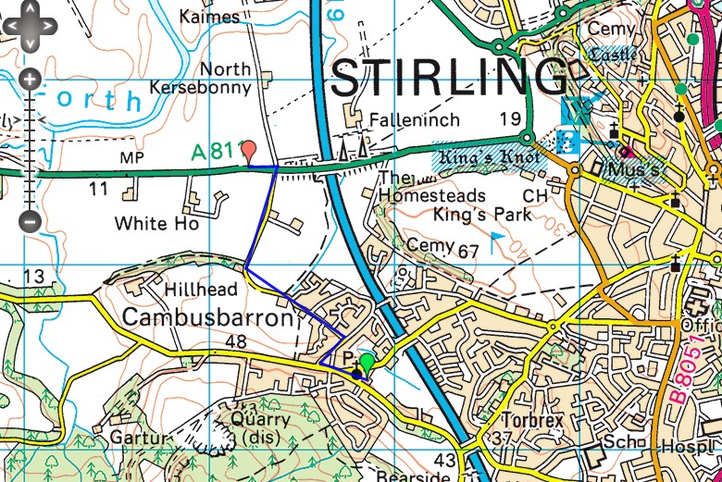

The course will be well signposted and marshalled.

Please note that Kippen Roundabout is encountered 2 times, and Clay Toll (Kings Knott) Roundabout once during the race.
Please take care at the 2 Roundabouts, with the Clay Toll mini roundabout being the busier of the two.

Race

- There will be limited space at the start area. riders are requested to arrive no more than 5 minutes before their start time, but remember to give yourself sufficient time if riding from Cambusbarron.
- Riders MUST have a working front and rear light fitted to their bikes. NO lights NO start.
- Riders should NOT stop at the finish area and should continue to the HQ where they need to SIGN OUT. If you don’t sign off, you will be recorded as DNF.

The Organiser extends his thanks to all the volunteers helping today, as without their participation the race would not be able to go ahead.

Prize Giving/Results will be at HQ after all riders are finished.

